HEALTH COORDINATION plan for Children and Young People with Complex health care needs with additional vulnerability.

The following patient was discussed at the health professionals meeting (TAC).
V18 FINAL Feb 2023
Patient Information
Meeting plan date |  | Last health coordination meeting and plan
First Name |  | Current Address
Surname |  | DOB / CHI
Lead Health professional – Name, Designation and Contact details.

Professionals attending.
PART 1 How I grow and Develop (Clinical Information)
Clinical Update
Diagnosis/Problems | Current Place of Care:
 | Palliative care Phase N/A / Stable / Unstable / End of life (Circle as appropriate)
Ethnicity | 1st Language spoken |  |  |  | Interpreter required YES / NO  Communication aids required YES / NO
Current active Health care plans.
Symptom management plan YES / NO
Free text i.e. Diabetes, Respiratory, epilepsy
Child & Young people’s acute deterioration management plan (CYPADM) YES /NO |  |  | Acute admission discharge plan YES / NO  Speciality service care plan YES / NO  Multi-disciplinary team meeting plan YES / NO
Anticipatory care plan (ACP) YES / NO
Does parent have a Digital parent held Passport YES / NO |  |  | “TRAK speciality alert” plan  YES / NO / NA
Care experience child (LACC) YES / NO | Child active on Child protection register YES / NO |  |  |  | GIRFEC Multi agency assessment / Child protection care plan active. YES / NO
Social worker involvement  YES / NO | Health visitor GIRFEC wellbeing assessment Plan  YES / NO |  |  |  | Health plan indicator:  CORE / Additional
Current wellbeing concerns.

PART 2 Planning( What I need from People Who Look After me)
My main care provider is Mum / Dad / Carer / residential home / hospital care

Details:
Assessment of current health needs:

Family background / Current circumstances / parental issues that might impact on ability to care for child:

Psychosocial update/ family circumstances i.e. – housing, employment, financial, inclusion issues. (My Wider World (Triangle)

Child/ Young person (…What Matters To me) and agree with Plan

Parents and Carer Views:

PART 3 PLANNING ACTION and REVIEW – Wellbeing indicator (SHANARRI -Safe, Healthy, Achieving, Nurtured, Active, Respected, responsible Included) Care Plan
Action | By Whom Name and designation |  |  |  |  | By When | Wellbeing Indicators  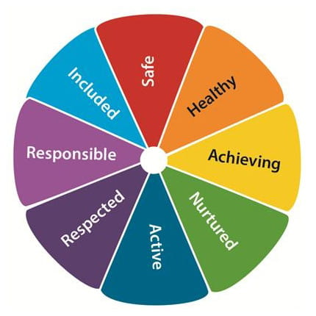
Health coordination plan review date
HEALTH TEAM of professionals involved.
Include all Community, Primary care, dental & Acute staff add boxes as required.
Name | Designation |  |  |  | Contact details please state if acute or community service.
 | Parents/ carers |  |  |  | Address if different from above.
 | GP

